# Lab: Visual Studio

Test your solutions in the **judge system**: <https://judge.softuni.org/Contests/4623/Visual-Studio-Lab>

## Hello SoftUni

Write a program that, **prints "Hello, SoftUni"** on the console.

### Instructions

1. Launch **Visual Studio.**
2. **Create a new project**:

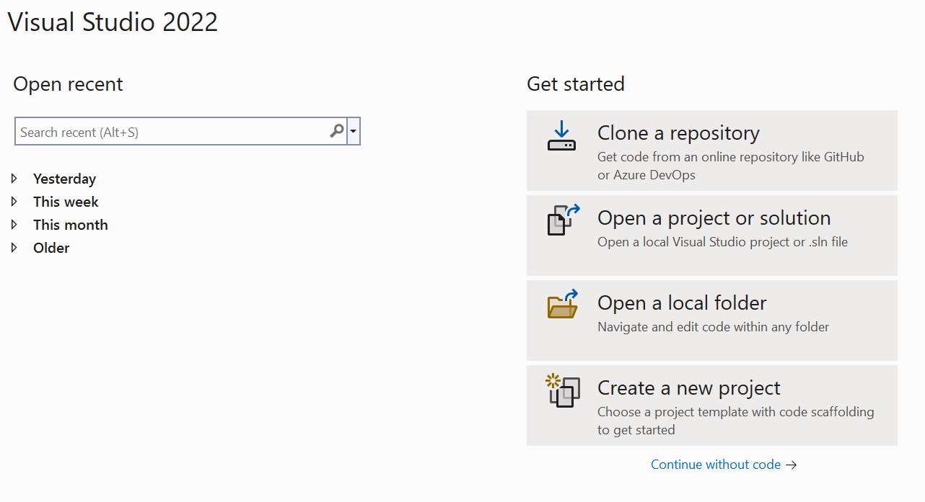

1. Select: **Console App (.NET Core)**

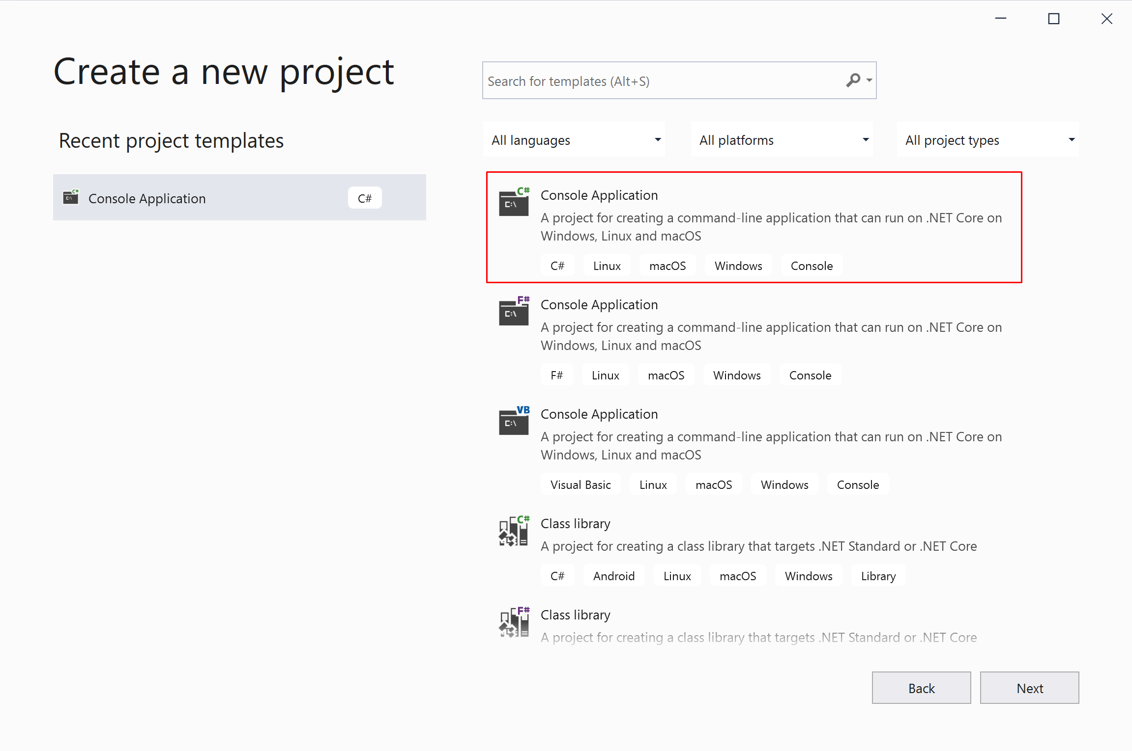

1. Enter a suitable **project name** and **directory** for the project to be created.

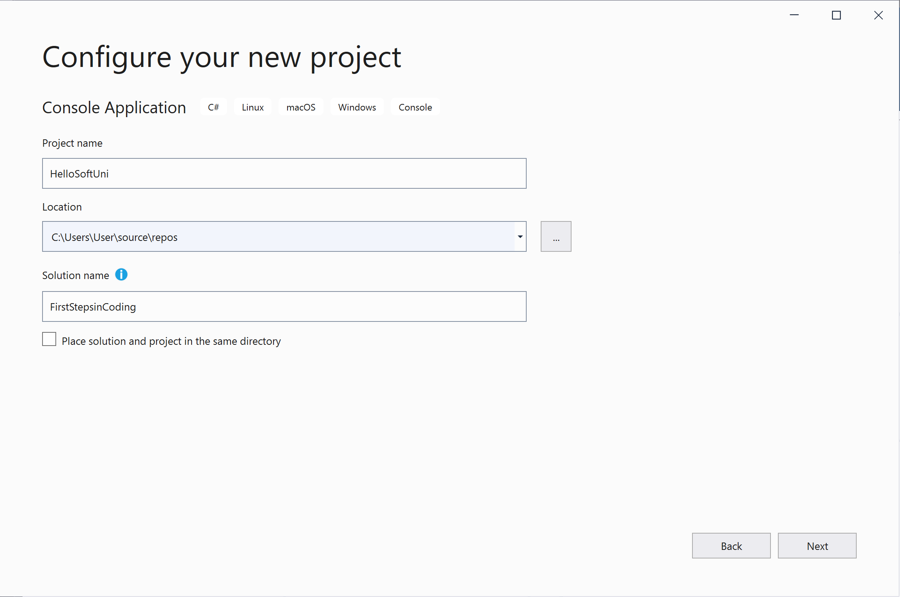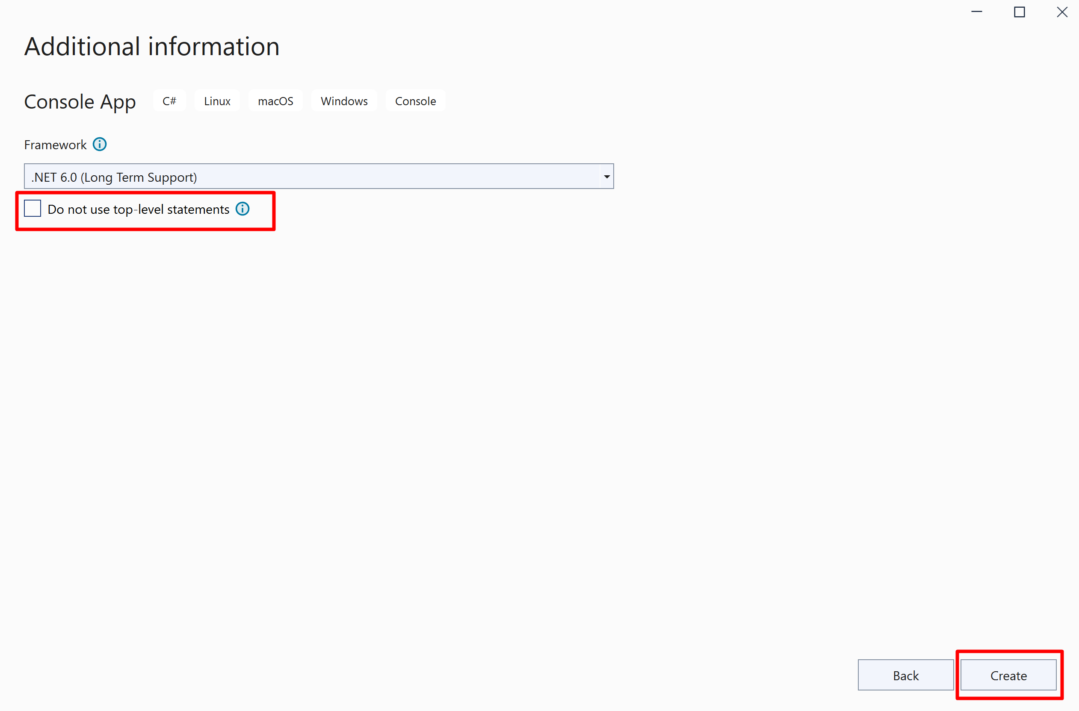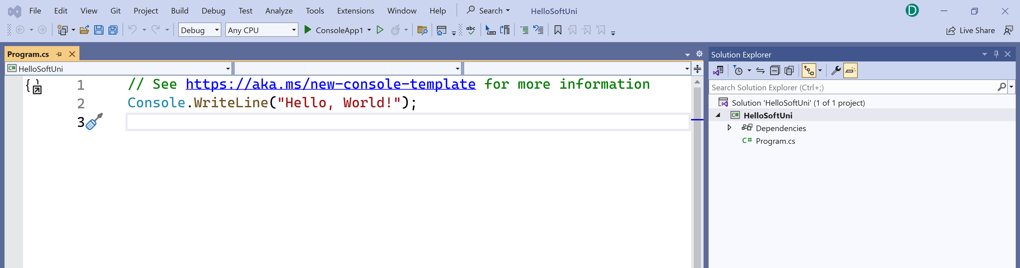

1. Write the following programming code (Command for printing text **"Hello, SoftUni"**):

|  |
| --- |
| Console.WriteLine("Hello, SoftUni"); |

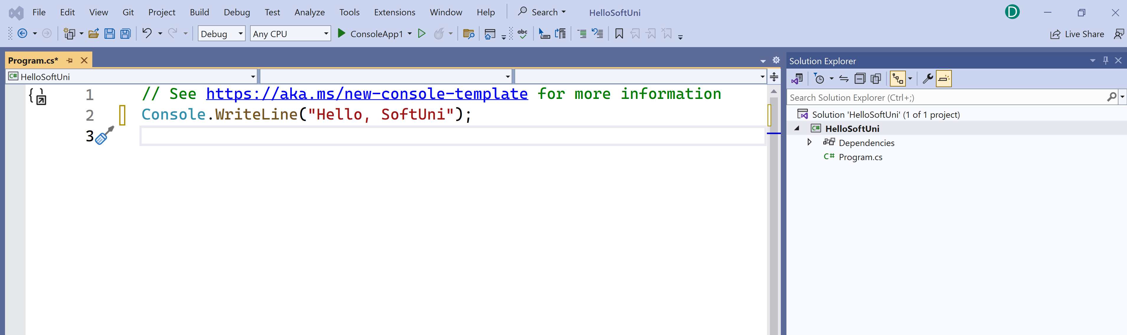

1. **Start** the program by pressing **Ctrl+F5**. You must see the following result on the **console**:

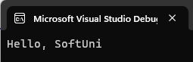

1. **Test your solution** for this task in the online **Judge system** of SoftUni
   * To do this first open [https://judge.softuni.org/Contests/Compete/Index/4623#0](https://judge.softuni.org/Contests/Compete/Index/4623%230)
   * **Log in** with your **SoftUni username**
   * A window for submitting solutions for the "Hello SoftUni" task will appear
   * **Copy the source code from Visual Studio** and paste it into the **submission field**:

Console.WriteLine("Hello, SoftUni");

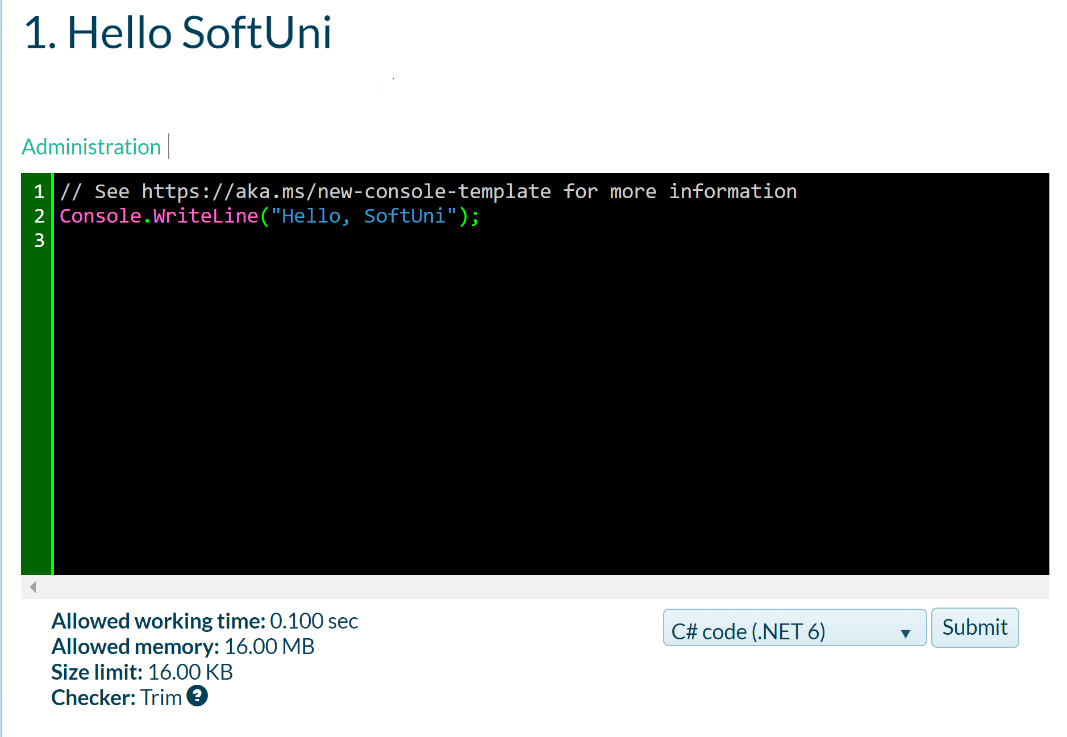

1. **Submit** your solution for evaluation using the **"Submit" button**. You will receive the **result after a few seconds** in the table of submitted solutions in the judge system:

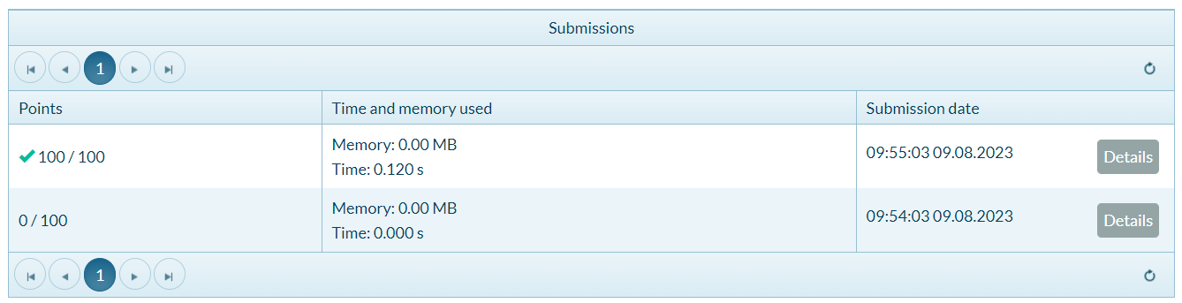

## Greeting

Write a program that:

* Reads from the console your **name**
* Prints **"Hello {name}"**

**namespace Customer**

**{**

**internal class Program**

**{**

**static void Main(string[] args)**

**{**

**// Prompt user for input**

**Console.WriteLine("Enter customer's first name:");**

**string firstName = Console.ReadLine();**

**Console.WriteLine("Enter customer's last name:");**

**string lastName = Console.ReadLine();**

**Console.WriteLine("Enter customer's email:");**

**string email = Console.ReadLine();**

**// Print customer info**

**Console.WriteLine($"Customer: {firstName} {lastName}");**

**}**

**}**

**}**

### Example

|  |  |
| --- | --- |
| **Input** | **Output** |
| Desislava | Hello Desislava |
| Ivan | Hello Ivan |

## Customer Info

Write a program that:

* Reads customer's **first name**, **last name** and **email**
* Prints the read data in the following format: **"Customer: {first name} {last name} ({email})"**
* **namespace Customer**
* **{**
* **internal class Program**
* **{**
* **static void Main(string[] args)**
* **{**
* **// Prompt user for input**
* **string firstName = Console.ReadLine();**
* **string lastName = Console.ReadLine();**
* **string email = Console.ReadLine();**
* **// Print customer info**
* **Console.WriteLine($"Customer: {firstName} {lastName} ({email})");**
* **}**
* **}**
* **}**

### Example

|  |  |
| --- | --- |
| **Input** | **Output** |
| Desislava  Topuzakova  d.topuzakova@softuni.bg | Customer: Desislava Topuzakova (dtopuzakova@softuni.bg) |
| Ivan  Ivanov  i.ivanov@abv.bg | Customer: Ivan Ivanov (i.ivanov@abv.bg) |

## Person Info

Write a program to read and print **info about a person**:

* Reads 4 lines of input: **first name, last name, country and town**
* Prints information about a person in the following format:

**"{first name} {last name} from {country} – {town}!"**

**namespace Person**

**{**

**internal class Program**

**{**

**static void Main(string[] args)**

**{**

**// Prompt user for input**

**string firstName = Console.ReadLine();**

**string lastName = Console.ReadLine();**

**string country = Console.ReadLine();**

**string town = Console.ReadLine();**

**// Print person info**

**Console.WriteLine($"{firstName} {lastName} from {country} - {town}!");**

**}**

**}**

**}**

### Example

|  |  |
| --- | --- |
| **Input** | **Output** |
| Desislava  Topuzakova  Bulgaria  Stara Zagora | Desislava Topuzakova from Bulgaria – Stara Zagora! |
| Ivan  Ivanov  England  London | Ivan Ivanov from England – London! |

## Town Info

Write a program to read and print **info about a town**:

* Reads 2 lines of input: **town** **name and country**
* Prints information about a town in the following format:

**"{town name} is in {country}"**

**namespace Town**

**{**

**internal class Program**

**{**

**static void Main(string[] args)**

**{**

**// Prompt user for input**

**string townname = Console.ReadLine();**

**string country = Console.ReadLine();**

**// Print person info**

**Console.WriteLine($"{townname} is in {country}");**

**}**

**}**

**}**

### Example

|  |  |
| --- | --- |
| **Input** | **Output** |
| Chiang Mai  Thailand | Chiang Mai is in Thailand |
| Sofia  Bulgaria | Sofia is in Bulgaria |